Part 1 Task 1:
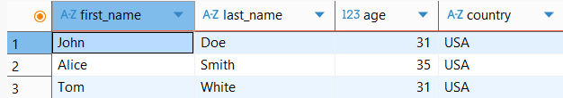
Part 1 Task 2:
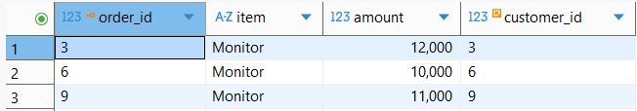
Part 2 Task 1:
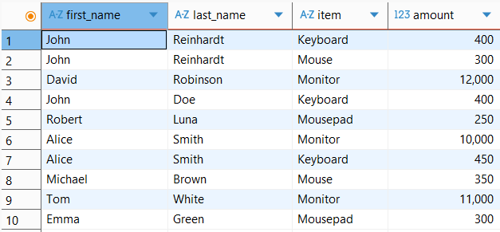
Part 2 Task 2:
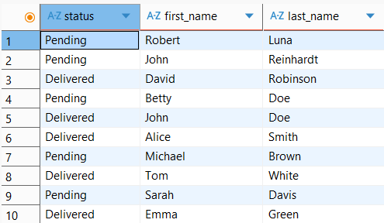
Part 3 Task 1:
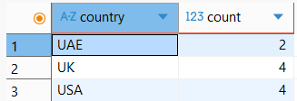
Part 3 Task 2:
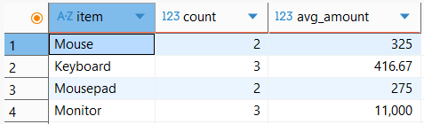
Part 4:
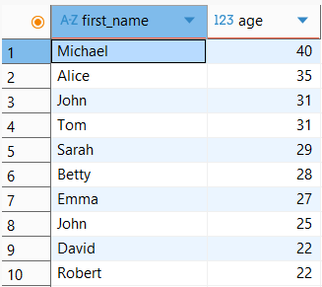
Part 5:
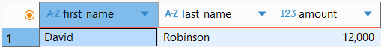
Part 6:
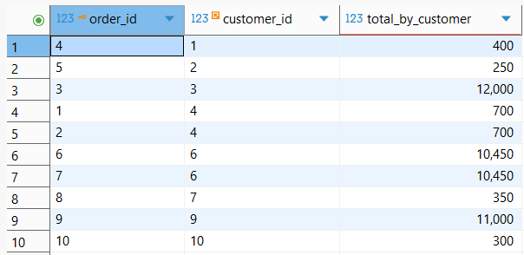
Part 7:

